CREATE IBM WATSON IOT PLATFORM AND DEVICE

|  |  |
| --- | --- |
| Team ID | ID PNT2022TMID016894 |
| Project Name | Real-Time River Water Quality Monitoring and Control System |

Step1:

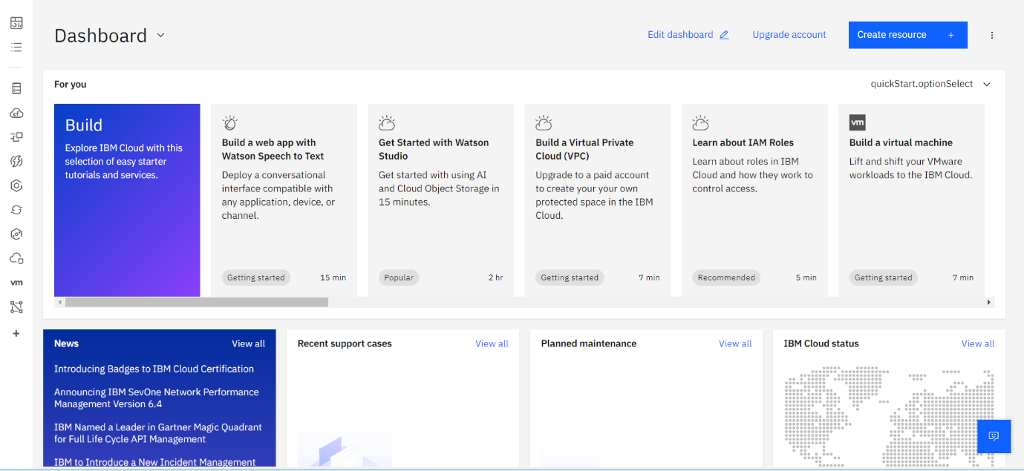

STEP 2:

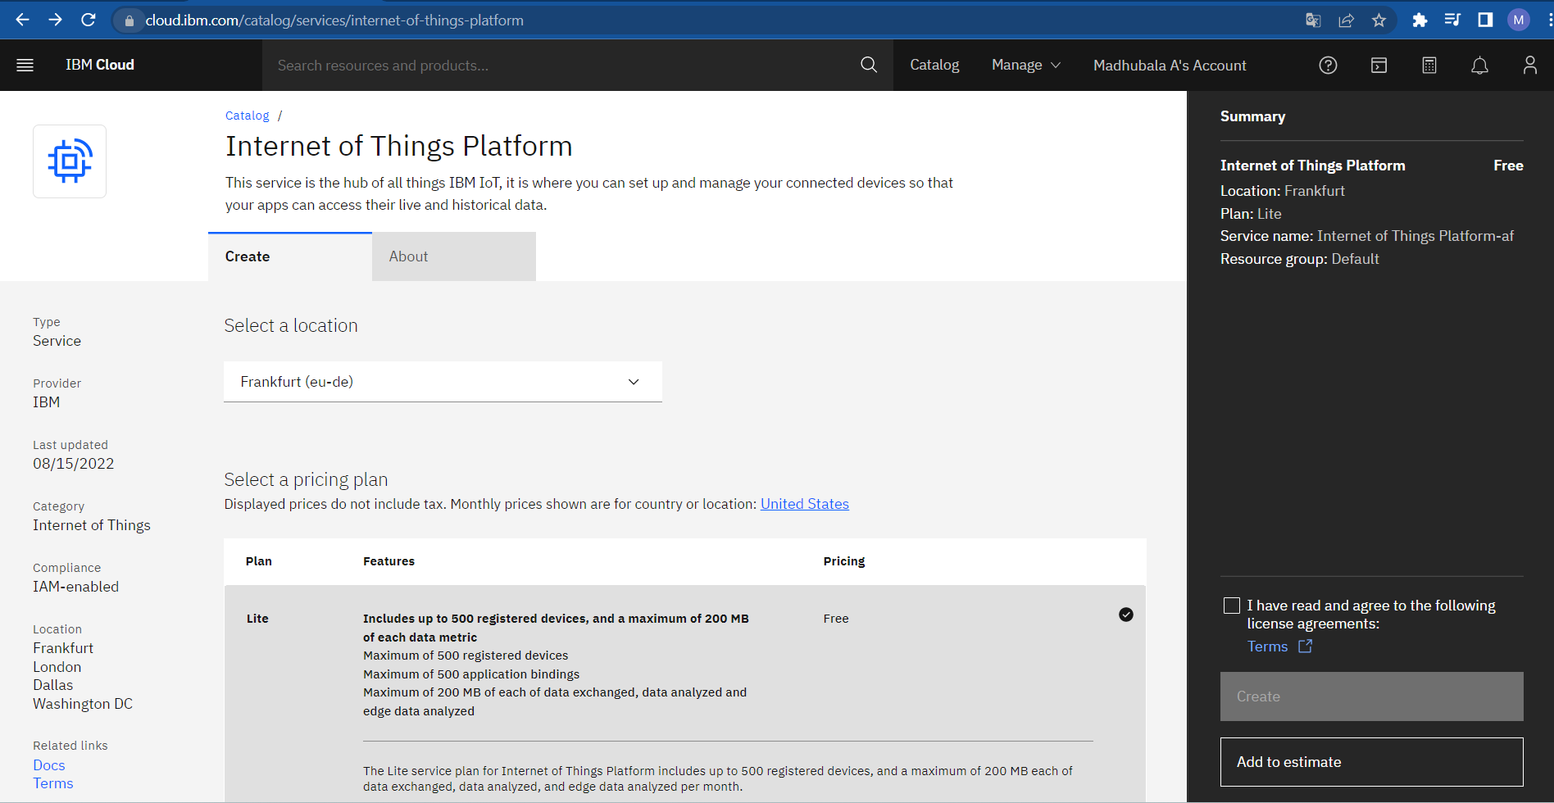

Step3:

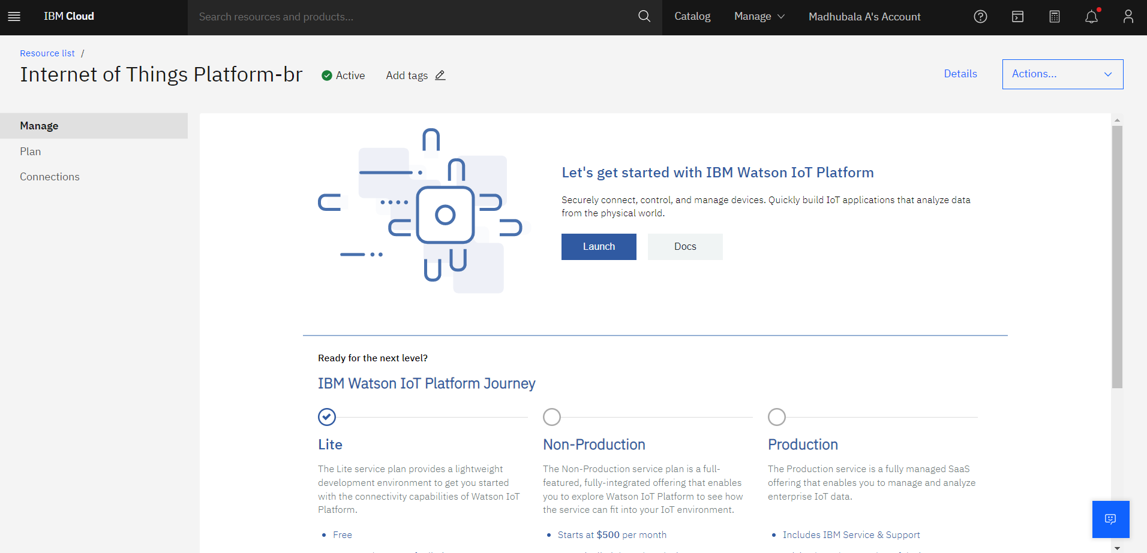

Step4:

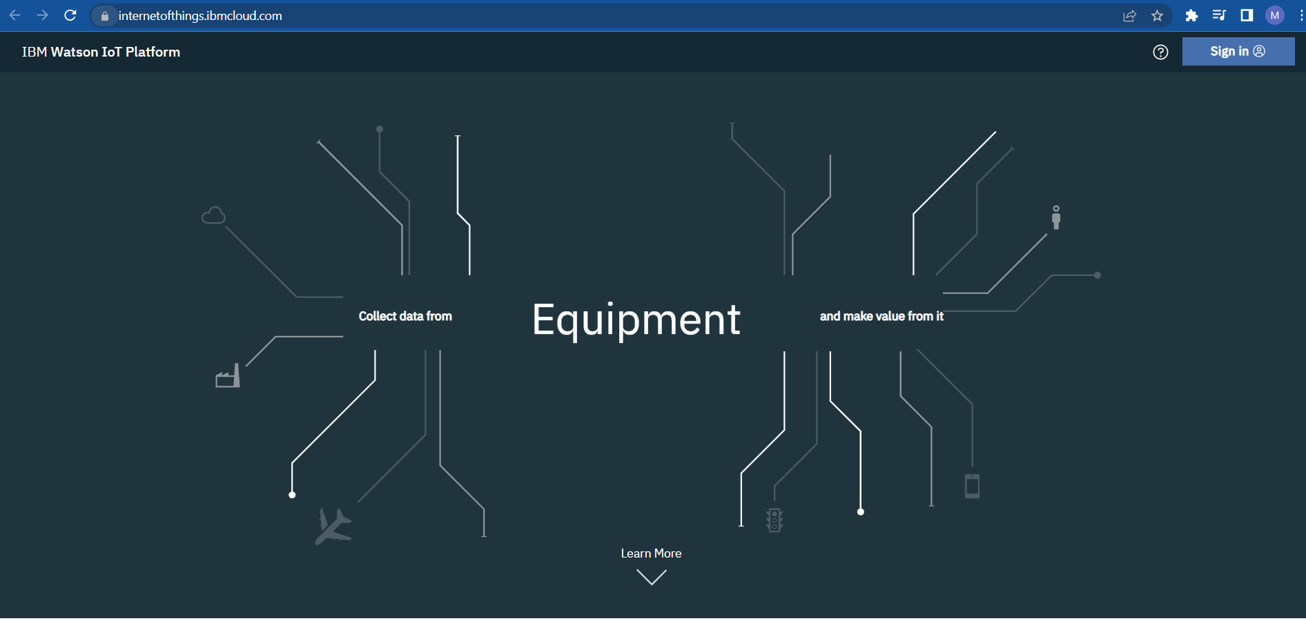

Step5: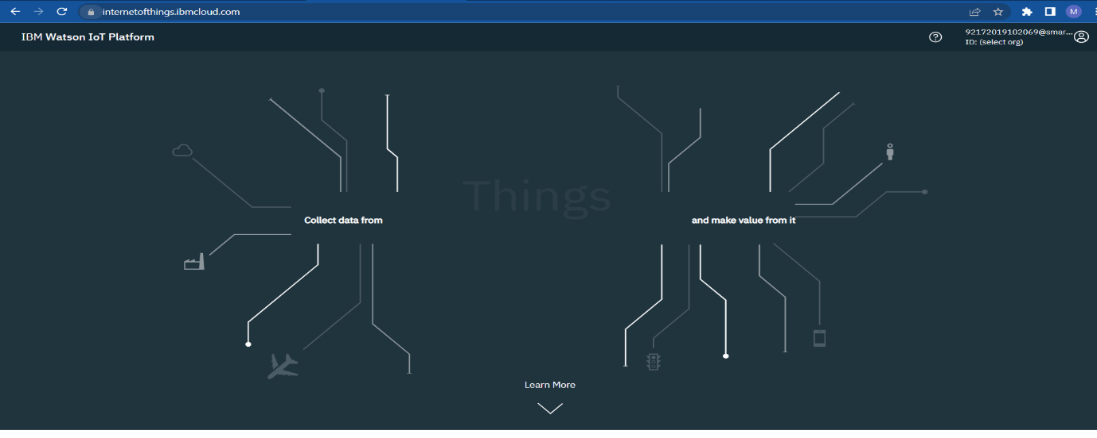

Step6:

